Patrick Townsend sFTP scripts creations
To create new definition, directory scan & auto scan following are required.
- Generate private and public key on iSeries
- Save Public and Private key in the IFS folder for the user associated or responsible to submit PT jobs to send / receive files. e.g. for MISOPR
  - /home/MISOPR/.ssh/id_rsa private key
  - /home/MISOPR/.ssh/id_rsa.pub public key
Once key generated, send public to associated partner server to apply the public on their server. Document Attached how to generate public and private key
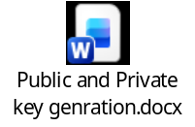
- Make sure user have authority and access to create/change/add access in all folders in both local and remote servers.
sFTP Setup – MAR4DEV
Private and Public keys have been generated and copied into following folder.
  - /home/MISOPR/.ssh/id_rsa private key
  - /home/MISOPR/.ssh/id_rsa.pub public key
sFTP server
Following SFTP server credentials are required
Server name : sftp.staples.ca
User-id : AS400SFTPTest
Password : C[!@_MdzQ&)WBLF7.R{hHZu3
Note: once public key applied on sftp.staples.ca server password is not required for Patrick Townsend’s definition, directory scan & auto scan configuration.

MAR4DEV1
Following IFS folders have been created for French translation testing
OUTBOUND
\Transfer\SDLTrans\Out\DropShip
\Transfer\SDLTrans\Out\Retail
\Transfer\SDLTrans\Archive\Out\DropShip

INBOUND
\Transfer\SDLTrans\In
\Transfer\SDLTrans\Archive\In
sftp.staples.ca
Following folders have been created in sftp.staples.ca server to send/receive SDL transaction
OUTBOUND
\ToBeTranslated\DropShip
\ToBeTranslated\Retail
INBOUND
\root\Archive
\root\SDLTrans\Translated

How to Create FTP Definition
ADDLIBLE ALLFTM100
GO AMMAIN
Option 2 Configuration
Option 2 Work with FTP definition
For this requirement following definitions have been created
- SDLTRANS French translation PUT DropShp
- SDLTRANSGT French Translation GET
- SDLTRANS1 French translation PUT Retails
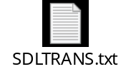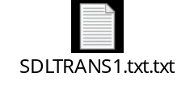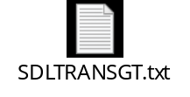
For each definition SFTP script has been created
Take option 3 – work with FTP scripts of Configuration menu following are scripts for above definitions.
- SDLTRANS TXT French Translation PUT Dropship files
- SDLTRANSGT TXT French Translation GET
- SDLTRANS1 TXT French translation PUT Retails
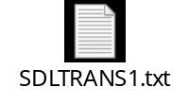
An addition script has been created for option14-Auto scan.
- SDLTRANSLS TXT French Translation GET option 14
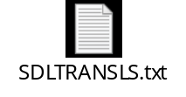
Scan Directory
Scan Director is required to select files from IFS folder and send them to sftp servers
Take option 5-Work with scan directory from Configuration menu and select Directory Scan definition in this case following are scan directories
- SDLTRANS French Translation PUT Dropship files
- SDLTRANS1 French Translation PUT Retail files
Take option 12 to define the files in IFS folder and send them to target folder
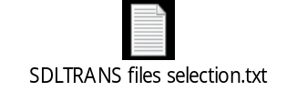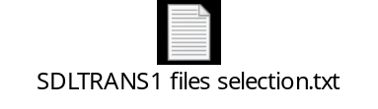
SDLTRANS for Dropship
Description . . . . . . . . .. French Translation PUT Dropship files
Path . . . . . . . . . . . .. /Transfer/SDLTrans/Out/Dropship
File action
Description . . . . . . . . .. *ANY files
Directory . . . . . . . . .. /Transfer/SDLTrans/Archive/Out/Dropship
FTP session name . . . . . .. SDLTRANS
lcd /Transfer/SDLTrans/Out/Dropship
cd /root/ToBeTranslated/Dropship
put *.*

SDLTRANS1 for Retail
Description . . . . . . . . .. French Translation PUT Dropship files
Path . . . . . . . . . . . .... /Transfer/SDLTrans/Out/Retail
File action
Description . . . . . . . . .. *ANY files
Directory . . . . . . . . .. /Transfer/SDLTrans/Archive/Out/Retail
FTP session name . . . . . .. SDLTRANS1
lcd /Transfer/SDLTrans/Out/Retail
cd /root/ToBeTranslated/Retail
put *.*

Auto Scan
Auto scan is required to select files from remote servers and uploaded into iSeries IFS folder
Take option 14-Work with auto scan from Configuration menu and select Auto Scan definition in this case following is auto scan definition
- SDLTRNSAUT French translation Auto Scan


Auto scan . . . . . . . . . . . .: SDLTRNSAUT
Secure Shell sFTP:
FTP definition . . . . . .. SDLTRANSGT
Exclude hidden files . . .. 1 1=Yes, 2=No
Delete after receiving . . .. 1 1=Yes, 2=No
SSH job user profile . . .. MISOPR
List files script . . . . . . SDLTRANSLS
Remote directory . . . . . .. /root/SDLTrans/Translated
Local IFS directory . . .. /Transfer/SDLTrans/In

French Translation High Level Draft
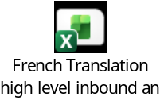

How to Start Directory Scan & Auto Scan
Make sure newly defined Directory and Scan definitions are in active state.
ADDLIBLE ALLFTM100
GO AMMAIN
Option 4-FTP Session Menu
First run option 11. End FTP Manager subsystem
Then start FTP Manager subsystem option 12

How to check logs and history
ADDLIBLE ALLFTM100
GO AMMAIN
Option 5-Inquiry
Option 1- Display application log
Option 2- Display FTP history

